**CHUKAUNIVERSITY**

**FACULTY OF SCIENCE, ENGINEERING AND TECHNOLOGY**

**DEPARTMENT OF COMPUTER SCIENCE**

**NAME: JARED MAGOMA THOMAS**

**REG NO: EB3/56448/21**

**ACSC 483: SOFTWARE PROJECT 1**

**PROJECT PROPOSAL FOR**

**ATTACHMENT & INTERNSHIP PLACEMENT**

**SUPERVISING LECTURER: MR. FREDRICK MUTHENGI**

**PROJECT PROPOSAL UNDERTAKEN IN PARTIAL FULFILMENT FOR THE AWARD OF BACHELOR OF SCIENCE IN APPLIED COMPUTER SCIENCE**

# **DECLARATION**

I Jared Thomas declares that this is my original work and has not been presented anywhere else to the best of my knowledge.

Student: Jared Thomas

Sign…………………………… Data…………………………………………….

# **APPROVAL**

This project proposal has been submitted with my approval as the university supervisor.

NAME: MR. FREDRICK MUTHENGI

SIGNATURE……………………… DATE………………….

# **ACKNOWLEDGEMENT**

I would like to express my gratitude to my project supervisor for their guidance and support throughout the course of this project. I also extend my thanks to my peers for their encouragement and assistance along the way.

# **ABSTRACT**

This project focuses on the development of a web-based Attachment and Internship Application System designed to streamline internship and attachment management processes within educational institutions. The current manual system is inefficient, error-prone, and resource-intensive, presenting challenges in data management and coordination between students, placement officers, and employers. The objective of this system is to provide an automated, secure, and user-friendly platform that facilitates efficient handling of student placement data, simplifies student registration processes, and improves interactions between institutions and employers. The system features include one-time registration, automated data management, and selective access to student resumes by companies, ensuring both functionality and data security.

The requirements and design were gathered through a combination of literature review, user interviews, and analysis of existing systems to identify key pain points and desired functionalities. The incremental development model was used to iteratively build the system, incorporating continuous feedback to ensure user satisfaction and adaptability. The proposed solution introduces a scalable and efficient platform that automates the placement workflow, reduces manual effort, enhances data security, and provides real-time accessibility for all stakeholders. This system ultimately aims to improve the overall experience for students, placement officers, and employers while promoting sustainability through reduced paper usage.

Table of Contents

**DECLARATION** 2

**APPROVAL** 3

**ACKNOWLEDGEMENT** 4

**ABSTRACT** 5

**CHAPTER 1: INTRODUCTION** 8

**1.0** **Introduction** 8

**1.1: Problem Statement** 8

**1.2: Existing System** 8

**1.3: Proposed System** 8

**1.4: Aim of this Project** 8

**1.5: Objectives** 8

**1.5.1 General Objectives** 8

**1.5.2: Specific Objectives** 8

**CHAPTER 2: LITERATURE REVIEW** 8

**2.0: Introduction** 8

**2.1: Attachments in kenya** 8

**CHAPTER 3: METHODOLOGY** 8

**3.0: Introduction** 8

**3.1: The incremental Model** 8

**3.1.1: Phases of the incremental model** 8

**3.2: Technology and Framework Used** 8

**3.3: Database System to be used** 8

**CHAPTER 4: SYSTEM ANALYSIS, REQUIREMENTS AND DEFINITION** 8

**4.1** **Introduction** 8

**4.2** **Existing System Architecture** 8

**4.3** **Proposed System** 8

**4.3.1** **Functional Requirements** 8

**4.3.2 Non-Functional Requirements** 8

**4.4: RESOURCES NEEDED** 8

**4.4.1: Hardware** 8

**4.4.2: Software** 8

**CHAPTER 5: SYSTEM DESIGN** 8

**5.0: Introduction** 8

**5.1: System Architecture** 8

**5.2: Database Design** 8

**5.3: User Interface Design** 8

**5.4: Security Design** 8

**5.5: Module Design** 8

**5.5.1: User Registration and Profile Management** 8

**5.5.2: Automated Data Entry and Updates** 8

**5.5.3: Placement Process Automation** 8

**5.5.4: Company Access to Student Resumes** 8

**5.5.5: Administrator Role** 8

**5.5.6: One-Time Registration and Upload Educational/Personal Information** 8

**5.5.7: Use Case Diagram for Attachment and Internship Application System** 8

**5.5.7.1: Actors** 8

**5.5.7.2: Use Cases** 8

**5.5.7.3: Relationships** 8

**5.5.7.4: Associations** 8

**5.5.7.5: Generalization** 8

**5.6: SYSTEM DESIGN DIAGRAMS** 8

**5.6.1: Flowchart of The System** 8

**5.6.2: Use Case Diagram** 8

**5.6.3 Database Design and System Requirements** 8

**5.6.4 Security measures** 8

**References** 8

**APPENDICES** 8

**1.0: TIME PLAN** 8

**1.1: BUDGET** 8

# **CHAPTER 1: INTRODUCTION**

## **Introduction**

The **Attachment and Internship Application System** is designed to replace manual processes that currently slow down operations and cause inconsistencies in the placement process. This web-based platform aims to efficiently manage student placement data within the institution. Its main objective is to provide quick access to placement-related activities and ensure that student information is accurately maintained. Upon logging in, students will be able to upload their personal and academic details. One key feature of this system is its one-time registration, simplifying the process for users. The placement cell will also use the system to invite companies for campus interviews and help them select suitable candidates for job opportunities. The system grants companies ’selective access to student resumes, enabling them to filter profiles according to their specific needs. Administrators will manage the placement details of selected students. The system is built to maintain a comprehensive database of student records and generate lists of candidates that meet a company’s recruitment criteria.

## **1.1: Problem Statement**

The current manual method for managing student placements in educational institutions is highly inefficient, resulting in delays and numerous issues, such as inconsistencies and unclear processes (Baird & Mollen, 2023). The lack of a streamlined system causes extended timelines for placement activities and makes it difficult to maintain accurate student data. This creates challenges for both students and placement officers, as the existing system does not offer a cohesive platform for effective data management or provide a standardized way for students and companies to interact. Additionally, without a centralized system, students face difficulties in quickly uploading their personal and academic details, which negatively affects the overall placement process. There is a pressing need for a comprehensive, web-based system that automates and streamlines these processes, ensuring faster access, accuracy, and a consistent approach to facilitate smooth interactions between students and employers.

## **1.2: Existing System**

The current system depends on manual processes for managing student information, which presents several challenges. Placement officers are responsible for entering student data, and any necessary updates or changes to student profiles must also be made manually. This method is laborious, time-intensive, and susceptible to mistakes.

The key drawbacks of the current system include:

1. **Manual Processes:** The system relies entirely on manual handling, which is both time-consuming and inefficient.
2. **Cumbersome Updates:** Updating or modifying student profiles requires manual input, leading to delays and potential errors.
3. **Data Security Risks:** There are inadequate security measures in place, which threatens the safety and confidentiality of student information.
4. **High Labor Demand:** The manual system requires significant human resources, leading to increased operational costs.
5. **Resource Intensive:** The system consumes large amounts of paper and physical storage space due to the volume of data being processed.
6. **Scalability Challenges:** As the number of users grows, managing the system becomes more complex and difficult to scale effectively.

## **1.3: Proposed System**

The proposed system seeks to overcome the challenges of the current manual method for managing student placement information. It will utilize modern web-based technology to provide an efficient, secure, and user-friendly platform for managing student profiles and placement-related tasks.

**Key Features of the Proposed System:**

1. **Automated Data Management:** This system will automate the handling of student data, minimizing the need for manual data entry and updates. Students will have the ability to manage their profiles independently, ensuring data is accurate and up-to-date.
2. **Improved Security:** Strong security measures will be implemented to protect student data, ensuring its confidentiality and preventing unauthorized access.
3. **Reduced Resource Usage:** By replacing paper-based methods with a digital system, the platform will drastically reduce paper consumption and physical storage needs, promoting sustainability.
4. **Scalability and Ease of Use:** The system will be built to support an increasing number of users without affecting performance. Its intuitive, user-friendly design will make it easy for all users to navigate and access the system.

## **1.4: Aim of this Project**

The goal of the **"Attachment and Internship Application System"** project is to create a web-based platform that effectively manages student placement information within educational institutions. The project’s objectives are as follows:

1. **Eliminating Manual Processes:** This project seeks to remove manual tasks that currently cause delays and inconsistencies in the placement workflow.
2. **Streamlined Student Information Management:** The system is designed to make handling student information more efficient, ensuring easier access and improved accuracy for personal and academic details relevant to placements.
3. **One-Time Registration Feature:** The system will include a one-time registration process, simplifying the user experience and making it more user-friendly.
4. **Facilitating Company-Student Interactions:** The platform will enable better communication between students and companies by allowing companies selective access to student resumes, based on their hiring needs, enhancing transparency and effectiveness in the placement process.
5. **Comprehensive Student Records:** It will maintain detailed student records and generate lists of candidates that meet the specific criteria set by companies for recruitment.
6. **Automation of Placement Procedures:** The system will automate critical processes, such as company invitations, scheduling campus interviews, and matching students with appropriate job roles. This automation is expected to improve efficiency and reduce the need for manual labor.

## **1.5: Objectives**

## **1.5.1 General Objectives**

* To develop a comprehensive web-based system that streamlines the management of internship and attachment applications, improving efficiency, accessibility, and coordination within educational institutions.

## **1.5.2: Specific Objectives**

The specific objectives define the clear, measurable outcomes the system is designed to accomplish, providing a more detailed view of its functions and expected results.

* To enable efficient creation, management, and closure of placement drives by administrators and coordinators.
* To provide a secure platform for users to register and gain approval for system access.
* To facilitate the posting, updating, and sharing of notices with relevant stakeholders.
* To manage and store technical papers for use by administrators and students.
* To allow users to create, update, and maintain their profiles with accurate information.
* To provide a means of communication between users and system administrators.
* To ensure secure access to the system through robust authentication and encryption methods.

#### **1.6: Justification**

The development of the Attachment and Internship Application System is essential to address inefficiencies in the current manual processes used by educational institutions (Esadia, 2021). These inefficiencies often result in delays, inaccuracies, and a lack of transparency, negatively impacting students, placement officers, and employers. A digital system will streamline these processes, enhance data security, and ensure a more organized and reliable approach to managing attachments. Furthermore, the system’s scalability and automation will reduce administrative workloads and improve the overall user experience.

#### **1.7: Scope and Limitations**

The proposed system is designed to facilitate the management of attachments and internships within educational institutions. It includes features such as student registration, automated data entry, placement process automation, and secure access for stakeholders, including students, placement officers, and employers. The system will support integration with institutional databases and provide real-time access to placement-related information.

**Limitations**:

1. The system’s functionality will be limited to institutions and organizations that adopt it.
2. It requires internet connectivity to operate, which may pose challenges in areas with limited access.
3. Initial setup and training for users may require significant resources and time.
4. Customization options will be limited to the predefined features and roles specified during the system’s development.

# **CHAPTER 2: LITERATURE REVIEW**

## **2.0:** **Introduction**

The literature review examines existing research, systems, and frameworks relevant to attachment and internship processes in educational institutions and industries. The chapter explores the current landscape of attachments in Kenya, evaluates existing systems for managing attachments, identifies their limitations, and introduces a conceptual framework for the proposed system.

## **2.1: Attachments in kenya**

Attachments are structured, credit-bearing work experiences in a professional work setting where students acquire and apply knowledge and skills (Kiplagat et al., 2016). Students typically have a faculty supervisor who addresses their needs and ensures academic and professional alignment. A logbook is used by students to document daily activities.

At the end of the attachment, students must submit a final report detailing their experiences and learnings. Faculty supervisors evaluate the student’s progress during the attachment, while training supervisors provide additional assessments, often through visits or surveys.

##### **2.1.1: Challenges Faced**

Existing attachment application websites have faced challenges in trying to place students in available attachments. These include crowded markets, wrong placement of students in attachments, and lack of connectivity between the universities and firms with attachment vacancies.

Some attachment application websites have an abundance of attachment vacancies for specific courses and minimal to none for other courses. It is easier for students pursuing science and business-oriented courses to get attachments than those pursuing humanity-oriented courses such as counselling psychology, public administration, or political science.

Another challenge is that some student attachment application websites place students in wrong attachments. Experts say that students find it hard to decide which organizations provide services in their areas of study. It therefore becomes difficult for students to know where to start looking for industrial attachment. When this happens, students find themselves in unrelated fields where they perform tasks that are unrelated to what they studied in school.

The other problem is that student attachment application websites are not connected touniversities. This has caused a lack of communication between students and firms with available attachment vacancies (Samwi, 2020). As a result, most students have missed available attachments.

##### **2.2: Existing Attachment Systems**

Various platforms and frameworks have been developed to facilitate internship and attachment management. This section evaluates prominent systems, identifying their strengths and limitations. There are systems that have been created for attachment seekers. They include NITA, Fuzu and LinkedIn.

##### **2.2.1: NITA**

The National Industrial Training Authority (NITA) is a state corporation established under the Industrial Training (Amendment) Act of 2011. It aims to promote the highest standards in the quality and efficiency of industrial training in Kenya and ensure an adequate supply of properly trained labor at all levels of industry.

It has been successful in helping students find attachments but has also faced challenges. These include stringent industry requirements, a slow and lagging website, and crowded markets. The NITA website requires its applicants to provide a number of documents before placing them in the right attachments, making the application process long and tedious.

Users have also complained that the website is unreliable, with occasional inaccessibility or slow responses. This has encouraged many users to look for alternatives when applying for attachments. Furthermore, the NITA website provides more attachment opportunities for courses with a high number of students pursuing them as compared to other courses. For example, education students face fewer challenges in securing attachments due to the abundance of schools where they can teach. In contrast, courses like counseling psychology or public administration face fewer opportunities. As a result, the NITA website has more vacancies for education-related fields but fewer for other courses. The National Industrial Training Authority (NITA) is a Kenyan government agency tasked with overseeing industrial training (Musyoki &Kilika, 2017). NITA maintains a centralized database for attachment placements and provides a platform for employers to advertise opportunities. While effective in promoting transparency, the NITA system is limited in its accessibility and user-friendliness. Additionally, its reliance on manual data entry for certain processes introduces inefficiencies and potential inaccuracies.

##### **2.2.2: LinkedIn**

LinkedIn is a globally recognized professional networking platform that offers tools for job and internship searches. Students and graduates use LinkedIn to connect with potential employers, showcase their skills, and apply for opportunities. While LinkedIn excels in providing a vast pool of opportunities and professional networking capabilities, it is not tailored to the specific needs of educational institutions managing student attachments. The lack of integration with institutional systems and limited support for administrative oversight are significant gaps.

##### **2.2.3: Fuzu**

Fuzu Limited launched the Fuzu service in Kenya in 2015. Fuzu combines the strengths of the world-renowned Finnish education and innovation systems with deep understanding of the end-user, their needs and aspirations in the African context. Fuzu aims to change the landscape of job and attachment search into an ever-inspiring journey of self-discovery. It is a web-based application with the main aim of linking job and attachment seekers to available job and attachments.

Fuzu is designed to carry the attachment seekers beyond disappointments by setting focus on the future. The system requires the user to insert their skill it will then use that information to match it with an attachment that requires the defined skill set and qualification.

However, Fuzu is mostly based on people who have already acquired the necessary requirements of a job including internship experience. They lack a lot of information on attachments vacancies and rarely update on any available vacancies. The website puts most of their resources on job seekers, attachment seekers have found this website useless when looking for attachments. Most students applying for attachments on this website have gone for months without getting a reply.

##### **2.3: Gaps of Existing Systems**

The existing attachment application systems lack choices and only focus on courses with high number of students undertaking them. This discourages students undertaking different courses that are not common. Other attachment application websites have subscription fees. Some have very high prices for their users and therefore discourage students from using these sites. Some of the systems are rarely updated and end up with dormant accounts. The dormant accounts reduce the number of available attachment vacancies as the system is not up to date.

The student attachment application is only for one function, which is to link students to available attachments and enables them acquire the required experience (De castro, 2019). The student attachment application online system will also be free for use and will only require connection to the internet.

##### **2.4: Conceptual Framework**

The student attachment application online system entities involved are; students, supervisor and the system administrator. The student creates an account, they then log in. They create a profile and fill all required fields. The firms’ supervisor in charge of attachments creates an account and logs into the system.

They upload the available attachment vacancies and also the academic achievements that an applicant should have, the supervisor also posts his/her name. The student uploads his/her CV to their attachment choice and waits for a reply. The supervisor in charge of the attachment is able to view the applications, if an application has been accepted, the supervisor is able to send an email with details of the attachment. The system administrator is able to make regular updates on attachment vacancies and maintains the system.

# **CHAPTER 3: METHODOLOGY**

## **3.0: Introduction**

Defining the methodologies for implementing the proposed web-based Attachment and Internship Application System outlines the steps and strategies for its development and deployment.

## **3.1: The incremental Model**

The incremental model will be used for the system's development, as it allows flexibility for future changes that users might require. In this approach, the system's requirements are divided into several independent modules. Each module goes through the stages of requirement gathering, design, implementation, and testing. With each phase, new functionality is added to the previous version, ensuring continuous progress until the system is fully developed.

Requirements

Testing

Implementation

Design

Specifications

***Figure 1.0:*** *Software development life cycle*

## **3.1.1: Phases of the incremental model**

1. **Requirement’s phase:** In this initial stage, analysts and project managers identify the system’s requirements and necessary functionalities. Understanding these requirements is crucial, as it forms the foundation for developing a solution that effectively meets user needs.

2. **Design and Development:** At this stage, the engineer translates the requirements into a structured system design. This involves creating working models and outlining how the system will function, as well as how its components will interact.

3. **Implementation**: The actual development of the software occurs during this phase. Coding and testing take place, and once complete, the software is deployed for use. Its performance is monitored to ensure it meets user expectations.

4. **Testing**: Testing is a vital step in the incremental model. During this phase, the software undergoes thorough testing using specific test cases to verify that all features and functionalities are working correctly. Once the software has passed all tests, it is delivered to the user.

## **3.2: Technology and Framework Used**

- Java

- Java Swing (for GUI)

- JavaFX (for enhanced graphical interfaces)

- MySQL (for database management)

## **3.3: Database System to be used**

MySQL – used to store data gathered from users and the information generated during the registration process.

## **CHAPTER 4: SYSTEM ANALYSIS, REQUIREMENTS AND DEFINITION**

## **Introduction**

The web-based attachment and internship application system is designed to improve the management of student placements within educational institutions by making the process more efficient. This section examines the limitations of the current manual system and outlines the requirements for the proposed digital solution.

## **Existing System Architecture**

The current manual placement management system relies on traditional, non-digital processes. Below is an overview of its structure:

**User Interface:**

The interface is primarily paper-based, using physical forms for tasks like student registration and placement-related activities.

**Manual Data Entry:**

Placement officers manually input student information into physical records or spreadsheets. Any updates to student profiles are done by hand.

**Document Storage:**

Important documents such as resumes, transcripts, and other records are stored in physical cabinets or folders. This storage method is vulnerable to damage, loss, and limited access.

**Placement Process Coordination:**

Placement officers manage the entire process manually, from scheduling campus interviews to handling company invitations and matching students with job opportunities.

**Communication:**

Communication between students, placement officers, and companies is mostly done through face-to-face meetings, phone calls, or traditional mail, with minimal use of digital tools. This can result in delays and coordination issues.

**Security Measures:**

Security relies on physical access control to storage areas. There is no encryption or advanced digital security to protect student information, making it dependent on the physical safety of the document.

**Reporting and Analytics:**

Reports and analytics are manually compiled from physical records, which makes the process time-consuming and unable to provide the real-time insights that a digital system could offer.

**Scalability Challenges:**

The manual system struggles to scale effectively as the number of students and placement activities increases, making it more difficult to manage larger volumes of data.

**Human Resource Intensiveness:**

The system relies heavily on human labor for data entry, coordination, and communication, resulting in higher operational costs.

**Limited Accessibility:**

Access to student information and placement data is confined to the physical locations where records are stored, limiting the ability to access data remotely or receive real-time updates.

**Environmental Impact:**

The current system increases environmental impact due to high paper consumption and limited digital documentation.

Overall, the existing manual system is labour-intensive, error-prone, and lacks the efficiency and accessibility that modern web-based solutions provide. Shifting to a digital system would address these issues and improve the management of the placement process.

## **Proposed System**

## **Functional Requirements**

**User Registration and Profile Management:**

* Users, including students, placement officers, and administrators, should be able to register on the system. They should have the ability to create, edit, and manage their profiles.

**Automated Data Entry and Updates:**

* The system should enable automated data entry for new student registrations. Students and administrators should also be able to update profile information easily.

**Secure User Authentication:**

* Access to the system must involve secure authentication procedures, such as multi-factor authentication, to ensure robust security.

**Placement Process Automation:**

* Key processes, including company invitations, campus interview scheduling, and matching students with job opportunities, should be automated within the system.

**Company Access to Student Resumes:**

* Companies should have selective access to view student resumes, allowing them to filter profiles based on specific job criteria.

**Administrator Role:**

* The system should include an administrator role responsible for managing and overseeing the placement process, including providing job details for students who have been placed.

**One-Time Registration:**

* Students should complete a one-time registration to simplify the setup process and minimize redundant data entry.

**Upload Educational and Personal Information:**

* Students should be able to upload personal and academic information, such as resumes and other relevant documents.

# **4.3.2 Non-Functional Requirements**

* **Security:** The system should implement encryption for data both in transit and at rest, and it should strictly enforce access controls and user permissions.
* **Scalability**: The platform should be designed to scale efficiently, handling a growing number of users and increased data without sacrificing performance.
* **Usability:** The user interface should be intuitive and easy to use, ensuring that individuals with varying technical skills can navigate the system smoothly.
* **Performance:** The system should maintain optimal response times (under 2 seconds) for regular operations, even during peak usage.
* **Reliability:** The system should maintain a high availability rate of at least 99.5%, with backup and recovery mechanisms in place for system failures.
* **Compatibility:** The system must be compatible with all major web browsers and responsive across multiple devices. It should integrate seamlessly with existing institutional databases and systems.
* **Environmental Impact:** The system should promote environmental sustainability by reducing the need for paper through the use of digital documentation and communication.

# **4.4: RESOURCES NEEDED**

# **4.4.1: Hardware**

1. Monitor, Keyboard, Mouse
2. 4GB RAM.
3. 100 GB Hard disk drive.
4. 2.6GHz Processor.
5. USB drive.
6. Wi-fi router.

# **4.4.2: Software**

1. Windows Operating System
2. IntelliJ IDEA or Eclipse (for java development)
3. Java development Kit (JD).
4. MySQL Database.

# **CHAPTER 5: SYSTEM DESIGN**

# **5.0: Introduction**

System design plays a vital role in converting requirements into a comprehensive plan. This chapter outlines the design specifications and architecture for the **Attachment and Internship Application System.**

## **5.1: System Architecture**

The proposed system will follow a three-tier architecture:

* **Presentation Layer:** The user interface will be developed using Java Swing and JavaFX for responsive and dynamic design.
* **Application Layer:** The core logic of the system will be implemented using Java to handle user interactions, data processing, and business logic.
* **Data Layer:** MySQL will serve as the database management system to store and retrieve data efficiently.

DATA LAYER -MYSQL

APPLICATION LAYER: Java

PRESENTATION LAYER: Java Swing, JavaFX

## **5.2: Database Design**

The database will be composed of several tables:

* **Users:** Stores information about students, coordinators, and administrators.
* **Placement Drives:** Manages details of placement drives, such as dates, companies, and eligibility requirements.
* **Notices:** Stores notices posted by administrators for both students and coordinators.
* **Technical Papers:** Stores and manages technical papers uploaded by administrators.
* **Profiles:** Contains profiles for students and companies.

## **5.3: User Interface Design**

The user interface will be designed with simplicity and ease of use in mind. Different interfaces will be developed for students, coordinators, and administrators, tailored to their unique needs. Intuitive forms will facilitate data input and updates.

## **5.4: Security Design**

* **Authentication:** Secure user authentication will be implemented, incorporating multi-factor authentication for added security.
* **Data Encryption:** Data, both in transit and at rest, will be encrypted to ensure confidentiality.
* **Access Controls:** Role-based access controls will be enforced to manage security and ensure privacy.

## **5.5: Module Design**

## **5.5.1: User Registration and Profile Management**

* Users can register in the system by providing necessary details.
* User profiles can be updated to ensure accuracy and reflect current information.

## **5.5.2: Automated Data Entry and Updates**

* New student registrations will be automated, minimizing manual data entry.
* Profiles can be easily updated by both students and administrators.

## **5.5.3: Placement Process Automation**

* Automates company invitations, scheduling of campus interviews, and matching students with job opportunities.
* Coordinators can efficiently manage placement drives.

## **5.5.4: Company Access to Student Resumes**

* Companies will have selective access to view student resumes based on their specific job requirements.

## **5.5.5: Administrator Role**

* Administrators will oversee the entire placement process.
* They will manage job details for placed students and handle system-wide activities.

## **5.5.6: One-Time Registration and Upload Educational/Personal Information**

* Students will complete a one-time registration process to simplify the initial setup.
* Students can upload their personal and educational details, including their resumes.

## **5.5.7: Use Case Diagram for Attachment and Internship Application System**

## **5.5.7.1: Actors**

-Admin

-Student

-Coordinator

-Company Representative

## **5.5.7.2: Use Cases**

**1. For Admin**

**-Manage Placement Drives**: The admin can create, edit, and delete placement drives.

**-Post Notices:** Admin can post notices for students and coordinators.

**-Manage Technical Papers**: Admins can upload, modify, and remove technical papers.

**-Manage Users:** Admins can add, modify, or deactivate user accounts.

**-View Reports:** Admins can generate and view placement-related reports.

**2. For Student**

**-Register:** Students can register in the system.

**-Update Profile:** Students can update their personal and educational details.

**-View Notices:** Students can access notices posted by the admin.

**-Apply for Drives:** Students can apply for placement opportunities.

**3. For Coordinator**

-**Manage Placement Drives:** Coordinators can create, modify, and close placement drives.

**-View Notices:** Coordinators can access notices posted by the admin.

**-Review Applications:** Coordinators can review and update the status of student applications.

**4. For Company Representative:**

**-View Student Resumes:** Company representatives can view resumes of students who have applied for their job openings.

**-Post Job Openings:** Company representatives can post new job opportunities.

## **5.5.7.3: Relationships**

* The admin manages all users and system-related activities.
* Students, Coordinators, and Company Representatives interact with the system according to their specific roles.
* Coordinators can review student applications and manage placement drives.
* Company Representatives can view student resumes and post job openings.

## **5.5.7.4: Associations**

* The admin is involved in all key system functionalities.
* Coordinators and Company Representatives are connected with placement-related tasks.
* Students are linked to activities involving their profiles and applying for placement drives.

## **5.5.7.5: Generalization**

* All users (Admin, Student, Coordinator, and Company Representative) can be broadly classified as "System Users."

## **5.6: SYSTEM DESIGN DIAGRAMS**

## **5.6.1: Flowchart of The System**

A flowchart visually represents the step-by-step flow of processes within a system. In the context of the "Attachment and Internship Application System," the flowchart acts as a roadmap, showcasing the sequence of actions and decision points within the various functions of the system.

The main purpose of the flowchart is to offer a clear and structured visualization of how users interact with the system and how data flows through its different stages. It outlines the logical steps followed by students, coordinators, administrators, and company representatives, guiding them through the various features provided by the web-based application.

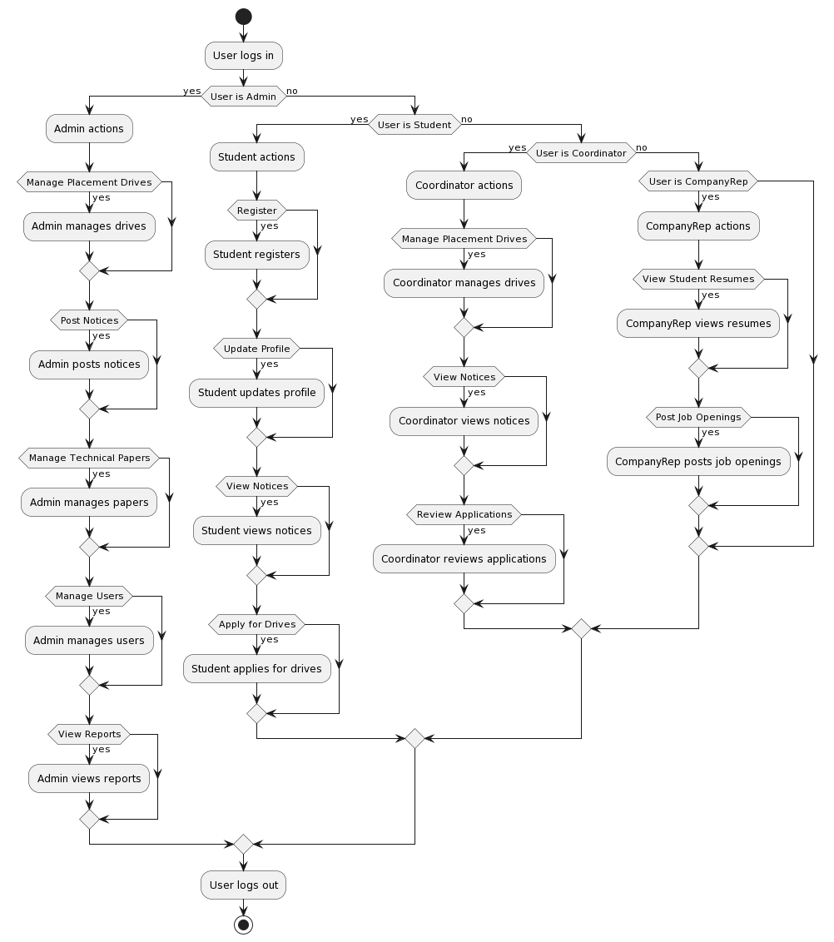

## **5.6.2: Use Case Diagram**

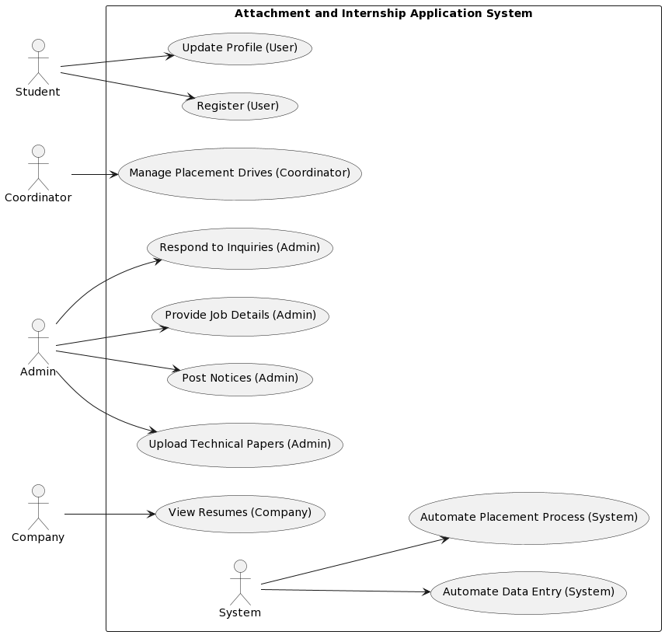

***Fig:3*** *Use Case Diagram*

+ StudentID INTEGER PK{

-- Name VARCHAR(255) NOT_NULL

-- Email VARCHAR(255) NOT_NULL

-- ...

STUDENT

COORDINATOR

+ CompanyID INTEGER PK{

-- Name VARCHAR(255) NOT_NULL

-- Email VARCHAR(255) NOT_NULL

-- ...

+ AdminID INTEGER PK{

-- Name VARCHAR(255) NOT_NULL

-- Email VARCHAR(255) NOT_NULL

-- ...

+ ProfileID INTEGER PK

-- StudentID INTEGER FK

-- CompanyID INTEGER FK

+ NoticeID INTEGER PK

-- Title VARCHAR(255) NOT_NULL

-- Content VARCHAR(1000) NOT_NULL

+ PaperID INTEGER PK

-- Title VARCHAR(255) NOT_NULL

-- UploadedBy VARCHAR(255) NOT_NULL

+ ApplicationID INTEGER PK

-- StudentID INTEGER FK

-- DriveID INTEGER FK

-- Status VARCHAR(50) NOT_NULL

+ InquiryID INTEGER PK

-- Name VARCHAR(255) NOT_NULL

-- Email VARCHAR(255) NOT_NULL

-- Message VARCHAR(1000) NOT_NULL

+ DriveID INTEGER PK

-- CompanyName VARCHAR(255) NOT_NULL

-- Date DATE NOT_NULL

DRIVE APPLICATION

INQUIRY

PLACEMENT DRIVE

**Fig 4:** Database Design

ADMIN

+ CoordinatorID INTEGER PK{

-- Name VARCHAR(255) NOT_NULL

-- Email VARCHAR(255) NOT_NULL

-- ...

COMPANY

(0,1) (0,1) (0,1) (0,1) (0,1)

TECHNICAL PAPER

NOTICE

PROFILE

## **5.6.3 Database Design and System Requirements**

-Database Management System: MySQL

-Web Server: Apache or Nginx

-Programming Language: Java for server-side and application development

-Front-End: Java Swing, JavaFX for graphical user interface

-Other Tools: IntelliJ IDEA or Eclipse for local development

## **5.6.4 Security measures**

**a) Password use**

The login process will be managed through password authentication.

**b) Validations**.

When users attempt to log into the system, their credentials will be verified against those stored in the database to ensure accuracy.

**c) Permissions**.

Users must log in to access the system's services and features.

**d) Passwords can be changed by users.**

Users will be able to change their passwords. After providing a valid email address, a token-generated link will be sent to the email matching the username, allowing users to reset their passwords within the system.

# **References**

Baird, B. N., & Mollen, D. (2023). *The internship, practicum, and field placement handbook: A guide for the helping professions*. Routledge.

Esadia, B. (2021). *A Microservices Based Student Industrial Attachment Information System Model for Technical and Vocational Education and Training Institutions in Kenya* (Doctoral dissertation, University of Nairobi).

Kiplagat, H., Khamasi, J. W., & Karei, R. L. (2016). Students’ experience of industrial attachment: A case of a public university.

Samwi, E. R. (2020). *Integrated students, coordinators and companies system for students’ field attachment coordination for Tanzanian higher learning institutions* (Doctoral dissertation, NM-AIST).

Musyoki, F. K., & Kilika, J. M. (2017). Effect of micro-environmental variables on implementation of industrial training projects among youth in Kenya: A case of National Industrial Training Authority. *International Academic Journal of Information Sciences and Project Management*, *2*(2), 218-238.

De Castro, R. M., & Pereira, D. I. F. (2019). Education and attachment: Guidelines to prevent school failure. *Multimodal Technologies and Interaction*, *3*(1), 10.

# **APPENDICES**

## **1.0: TIME PLAN**

**Introduction**

This is the timeline I will adhere to for completing my project on the Attachment and Internship Application System. The timeline outlines the activities and their durations, from the initial phase to the final implementation of the system.

|  |  |  |  |  |  |  |  |  |
| --- | --- | --- | --- | --- | --- | --- | --- | --- |
| Duration  Activity | 23rd October | 30th October | 30th  October | 30th October | 30th  October | 30th  October | 13th  November | 4th  December |
| Idea Presentation |  |  |  |  |  |  |  |  |
| Introduction |  |  |  |  |  |  |  |  |
| Literature Review |  |  |  |  |  |  |  |  |
| Methodology |  |  |  |  |  |  |  |  |
| Resources and Budget |  |  |  |  |  |  |  |  |
| Proposal Time Plan |  |  |  |  |  |  |  |  |
| System analysis and Requirements Specification |  |  |  |  |  |  |  |  |
| System design |  |  |  |  |  |  |  |  |

***Table 2****: Time Plan*

## **1.1: BUDGET**

The table below shows an estimated budget allocation used in the system development.

|  |  |
| --- | --- |
| ITEM DESCRIPTION | PRICE(KSH) |
| Laptop (PC) | 40,000 |
| MySQL Database server | 0.00 |
| Printing and Binding | 600 |
| USB Flash | 1200 |
| IntelliJ IDEA or Eclipse | 0.00 |

***Table 1****: Resources required and its cost*